Some language pointers!
How did you learn this?How could you best solve this problem?
Which learning muscles worked well for you? Which ones need more exercise?
Who can you notice learning well? What makes you say that? What did you see / hear them doing?
How did what you were talking about help you to learn?
Which way of learning worked best for you? Why?
Hmm, that’s an interesting way to talk about your learning.
That’s exciting. You’re not sure what to do next. What might you do to learn what to do?
What did you do then that really worked well for you?
What didn’t work so well? Can you think of reasons for that? What would you do in the future?

When you use this learning muscle, you…

Are interested in how you learn.
Can talk about what skills you need to get better.
Can talk about how learning works for you.
Know your strengths and weaknesses as a learner.
Are interested in becoming better learners.
Ways that we can foster the skill of Meta-Learning:-

Use real-life situations as opportunities to talk about learning. Scaffold learning through questioning and change approaches to suit different children.
Give children choices about how they learn and ask them to compare different ways of learning.
Give children time to relax and think about how they can do something best but also continually push the boundaries and challenge children with new ideas.
Knowing yourself as a learner – how you learn best; how to talk about the learning process.
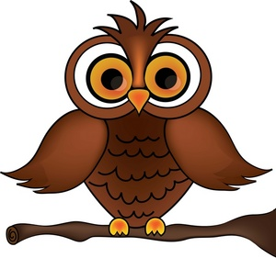
Meta-Learning

