When you use this learning muscle, you…

Look for connections between experiences or ideas.
Find pleasure in seeing how things fit together, make patterns.
Connect new ideas to how you already think and feel.
Look for analogies in your memory that will give you a handle on something complicated.

Ways that we can foster the skill of Making Links:-

Model noticing connections and links and talk about them explicitly.
Encourage the children to explain the links they identify.
Remind children of the links between skills and knowledge.
Pursue new knowledge enthusiastically in order to follow up connections which children or adults identify.
Be prepared to try something out to see if it will provide helpful connections.

Seeing connections between different events and experiences – building patterns – weaving a web of understanding.
Some language pointers!
How could it fit? What does…….. tell you about ………..?
Can you see any connections? Can you see a pattern here?
What do you know already that could help? What else do you know?
Can you see a link between what we did in ………… and what you do ………… ?
How might knowing ……………. help you to do…………….?
How many ideas can we think of here?
Can you think of a metaphor for this?
Ask yourself, what is this like that I already know about?
Now that you know …….. has it changed how you think about ……?
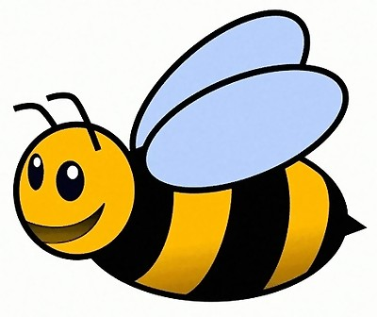
Making Links

