When you use this learning muscle, you…

Are not afraid of not knowing.
Are curious about things and people.
Like to get below the surface of things and come up with your own ideas.
Often wonder why.
Play with ideas, asking “how come?” and “what if?”

Ways that we can foster the skill of Questioning:-

Model using questions as the starting point of the quest for knowledge.
Adults to admit they do not know some of the answers to children’s questions and find out with them.
Encourage open, hypothetical and ‘big’ questions.
Consciously try to teach only what the children don’t already know.
Ask questions of ourselves as adults.
Reward good questions.

Asking questions of yourself and others. Being curious and playful with ideas – delving beneath the surface of things.
Some language pointers!
That’s a great / interesting / thoughtful / insightful question.
I don’t really know myself yet. I wonder what we could ask to find out.
If we had a real scientist / poet / author / mathematician here who could tell us anything we wanted to know, what would we ask?
When we find that out, what might we ask next?
What do you think an alien would ask here? What else might you want to know?
What questions did we ask last time? Is this a good enough answer?
What could this be? Why is it fun to ask questions?
Can you think of 5 questions that would give us this answer?
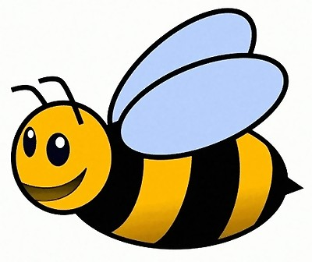
Questioning

